Appendix I

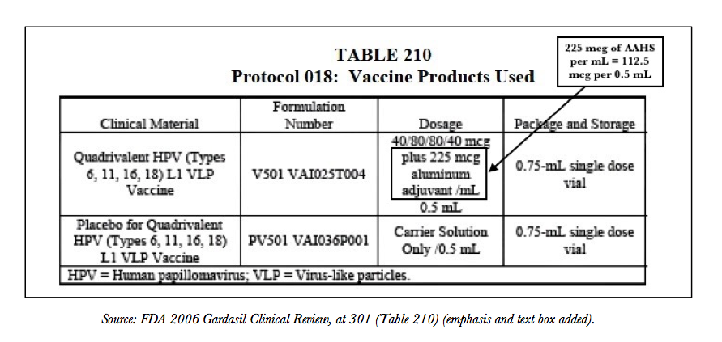
“Table 210 below describes the vaccine formulation as “per mL” (milliliter), but Gardasil is dosed by the half-milliliter. Simple division shows that the 0.5 mL dose administered in the 018 study contained only 112.5 mcgs (micrograms) of AAHS, as well as the standard ratio of the four HPV L1 VLPs.” – HPV Vaccine On Trial, Chapter 8.

Appendix II
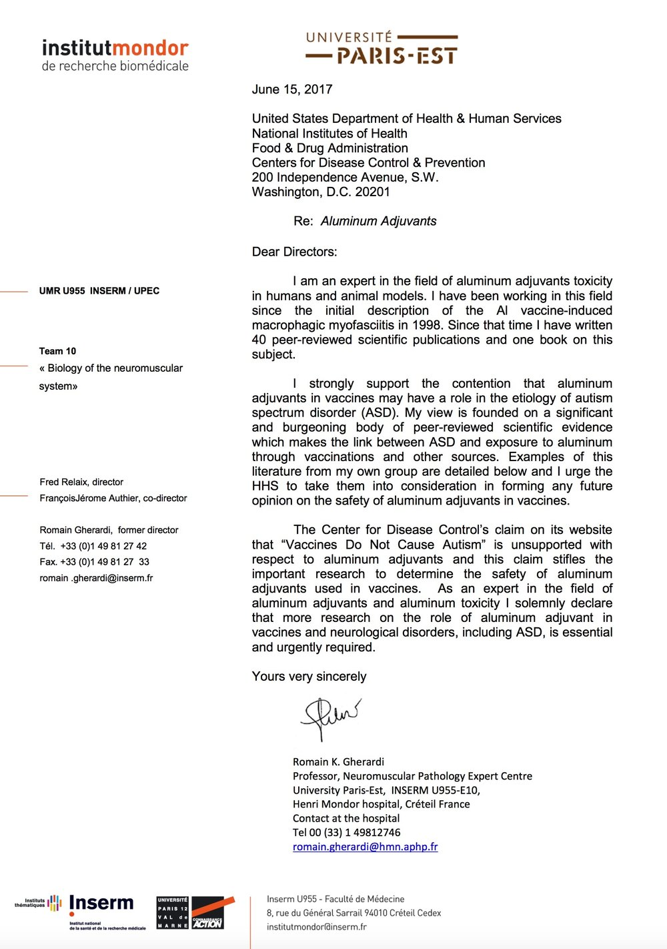
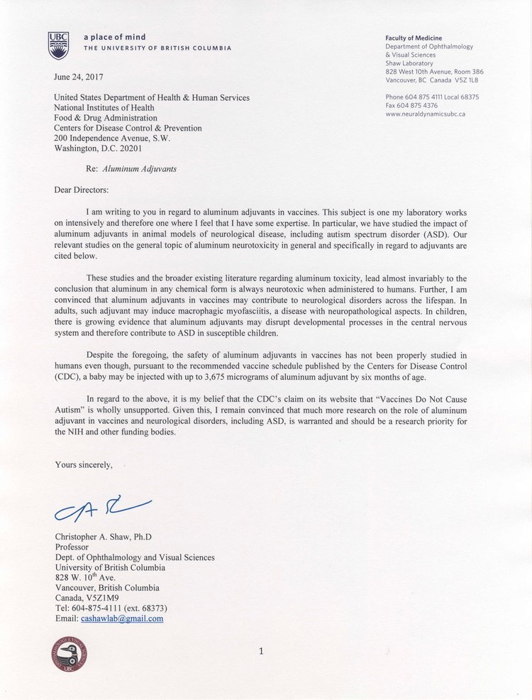

Appendix III

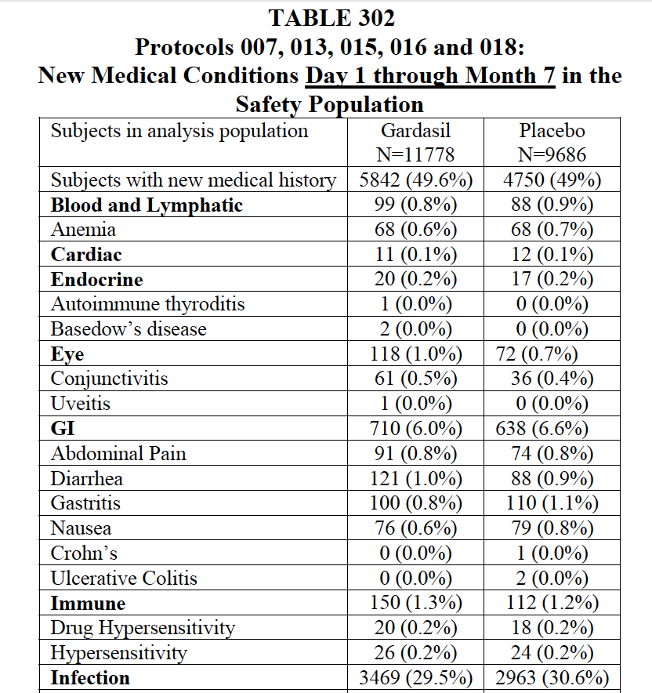

Sample of new medical conditions, source: 2006 FDA Clinical Review

